**HELEN KELLER**

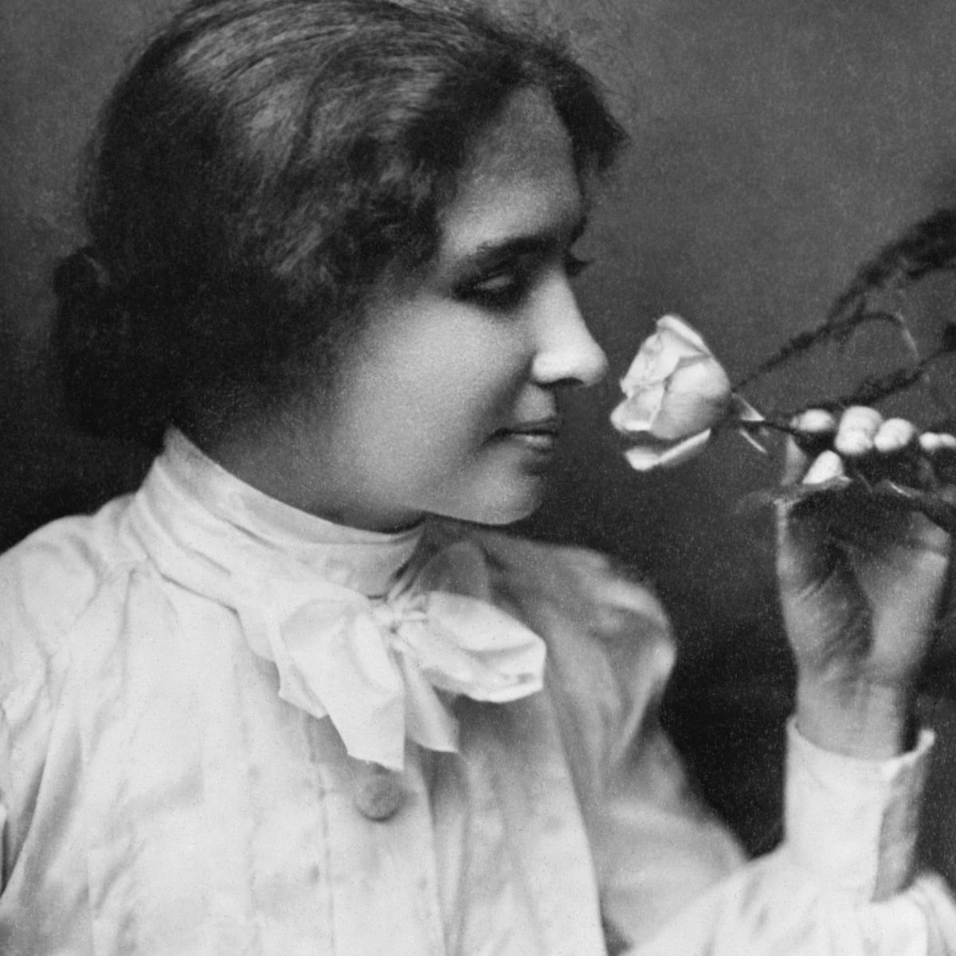

Despite her inability to hear,see,speak. Helen Keller became one of the first deaf and blind person to graduate college in the US. She was an advocate for communities of people with disabilities in many ways, raising awareness through her lecture circuits and books and raising funds for the American Foundation for the Blind.

**THOMAS ALVA EDISON**

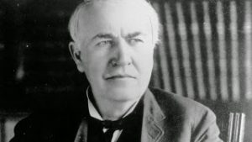

One of Edison’s most beautiful creation is the light bulb, without which we would be in the dark. Despite being deaf he invented Phonograph which is used in motion pictures. He designed a electric power generating system as well. He enjoyed being deaf and it helped him concentrate more on his work.

**LUDAWIG VAN BEETHOVEN**

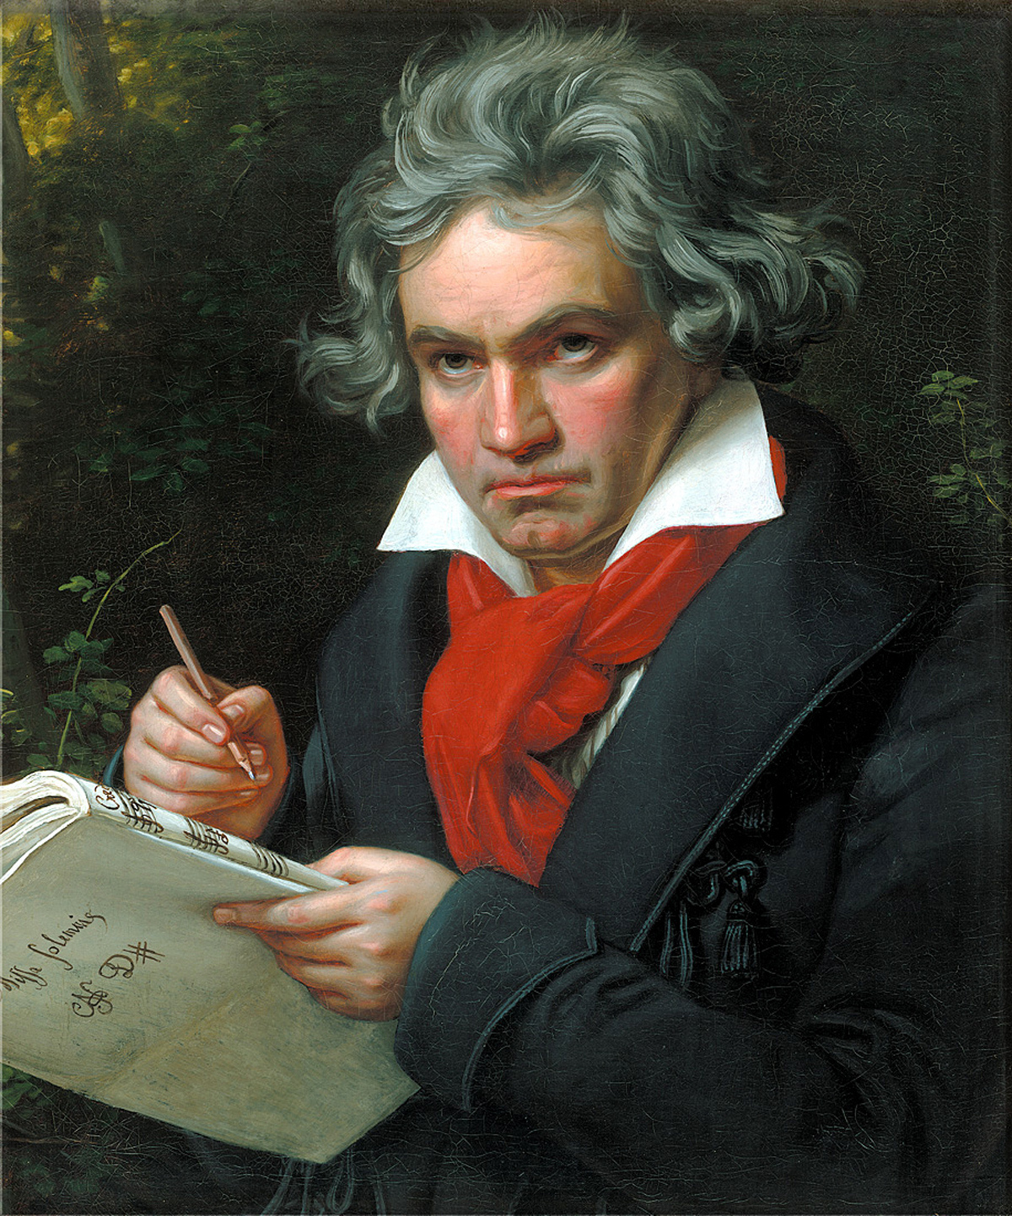

One of the greatest music composer Beethoven, became deaf around his mid 20’s. He could communicate with his colleagues and friends only through a pen and paper. Despite te struggle to know when the music stopped and audience applauded, Beethoven still performed and came out to be the best of all. He composed an album even after he became deaf which gained so much attention and appreciation. Beethoven's famous Symphony No. 5, written in 1804. Its famous opening motif is often referred to as 'fate knocking at the door'; the cruel hearing loss that he feared would afflict him for the rest of his life. The Ninth Symphony is known to be a classic written after he had gone completely deaf.

**MARLEE MATLIN**

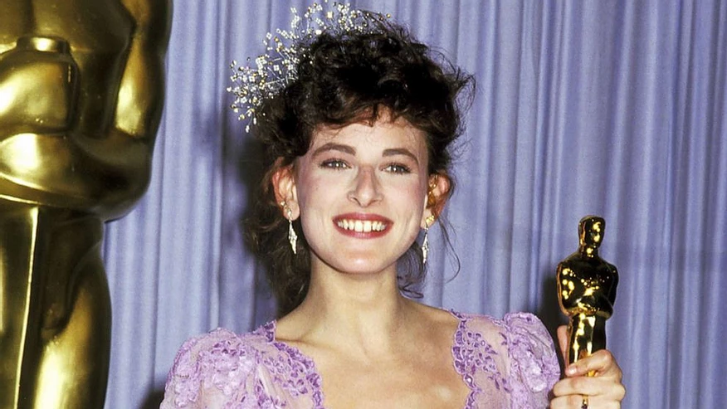

Marlee Matlin won the Academy award for Best Actress for her role in the romantic drama film “Children of a Lesser God”. This was her debut on the big screen and she went on to be the holder of many more awards, including three Golden Globe nominations, a star on the Hollywood Walk of Fame, and four Emmy Award nominations. Marlee was able to fulfil another lifelong dream of hers. She wrote a children’s book to tell the world about the experiences of Deaf people. In 2002, her dream became a reality and her first book, Deaf Child Crossing, was published.

**LINDA BOVE**

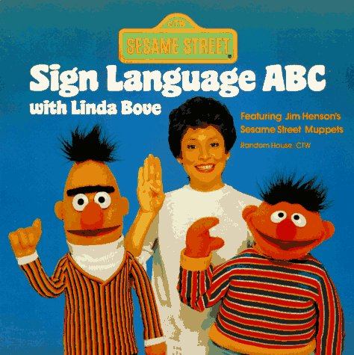

The sesame street has been a memorable children’s show for a very long time. Linda Bove’s first appearance came as a librarian in it. She helped millions of children and families understand the importance of sign language and encouraged the practice of it. Later she got a permanent role for about 30 years in the Sesame Street, which is a very long period for a deaf person in Hollywood.